**Hello there Champion !**

I hope you’re doing well, and ready to design a beautiful berries pokedex !

Before we start, some key notes:

1. You now have time for yourself to read, understand and implement as much as you want from this (important) mission. We will soon meet and you’ll tell me what you’ve been through, and continue with the implementation (I’ll try to be quiet - I promise).
2. To complete this mission, you’ll need to have an IDE of some sort that can run React components. This could be a local environment that you’ll create for yourself, or an online React playground that you’ve tested to work well (and not ask for money after 10 lines of code)
3. I may want to examine your code after the interview - so let’s assure that you have an easy way to share your output code with me
4. You may not complete the whole mission, but that doesn’t matter, what matters is the quality of your work, and the braveness that’s in your heart !

**“Ok, I’m in !”**

Good. what we’ll build today is a simple berries pokedex, which is a card in the middle of the screen, that would look like:  
(That’s a mock - the numbers and names are off)

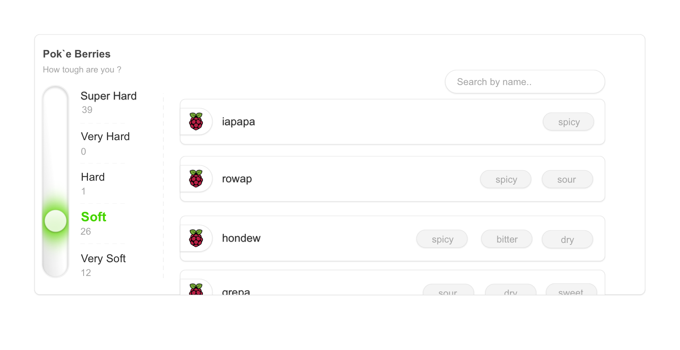

**Berries ? Which berries ?**

So in order to receive the various berries, you’ll fetch data from the pokemons API, which you may explore here: [**https://pokeapi.co/docs/v2#berries-section**](https://pokeapi.co/docs/v2#berries-section)

(I’d recommend you to start with this endpoint: <https://pokeapi.co/api/v2/berry>).

The API will provide you a ‘firmness’ level on each fruit, and a list of flavors with a potency level on each one. You’ll need to fetch the data of all available berries (there aren’t that many), and:   
  
A. Categorize them into their firmness level

B. Denote on each berry - what are its flavors (the ones with potency level above 0)  
  
**Ok, I’ve retrieved some berries, Explain the UI**

Let’s break the UI down:

You’ll make the card in the middle of the screen (Improvise sizes & colors - no figma is available here), then you’ll have 2 sides to implement  
1. The left side that we’ll call ‘The Firmness Slider’, which would have these states (visually):

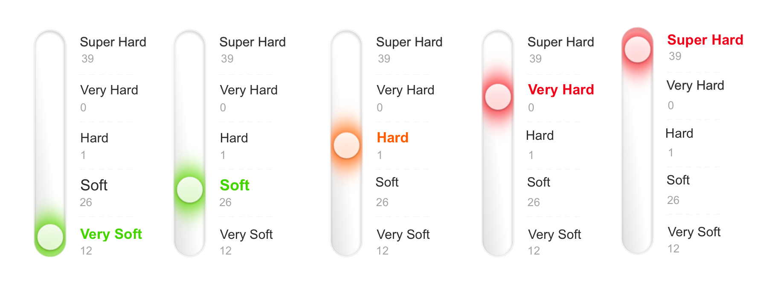

* Upon clicking on a firmness title - the slider would change, and would filter the right side to the selected firmness level
* The slider would change to the selected position with the right color etc..
* A **bonus** would be to make the slider move in a real sliding motion (that’d be cool), and an accurate design of the slider. (so we could start with a more basic design and improve iteratively)

2. The right side that we’ll call ‘The Berries Collection’ - A simple scrollable area with the berries cards.

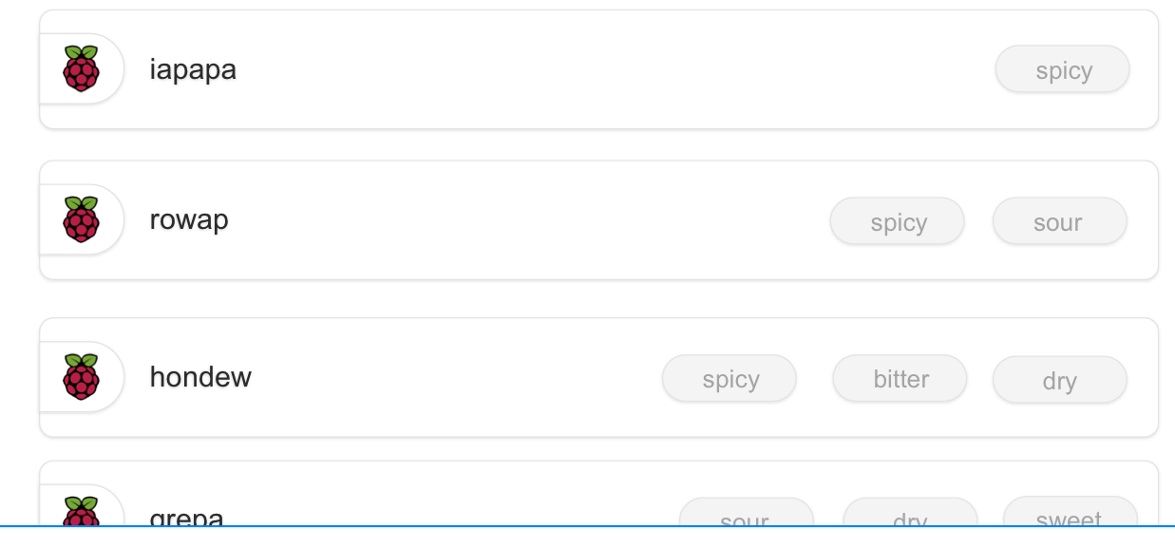

* A berry card would have the name on the left with a berry icon  
  (yea I know - that’s a raspberry pi logo, I was lazy.. You can attach the image from this src: <https://logowik.com/content/uploads/images/346_raspberry_pi_logo.jpg>)
* On the right side - there would be Chips components 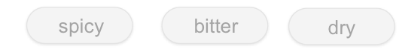 that would signify the flavors of the berry (with potency above 0).
* **Bonus**: Above the berries there is a ‘search by name’ text field 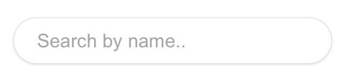, If you would be kind enough to implement the searching mechanism on top of the firmness filtering, it would be great.
* **Super Bonus**: If you would implement a debounce mechanism (When typing - wait for a second before actually filtering the berries) it’d be really cool..
* **Super Duper Bonus**: If this mechanism would be in a separated custom hook - That would be impressive !

If you have any questions, please save them for our session. In the meantime, feel free to make any assumptions you need regarding the implementation.